**Homework 3**

**(15 points) Problem 3:** The file sample.dat has **two** blocks A and B, explain in HDFS how this file is written to a Hadoop cluster with **one** namenode and **three** datanodes in a default configuration.

sample.dat

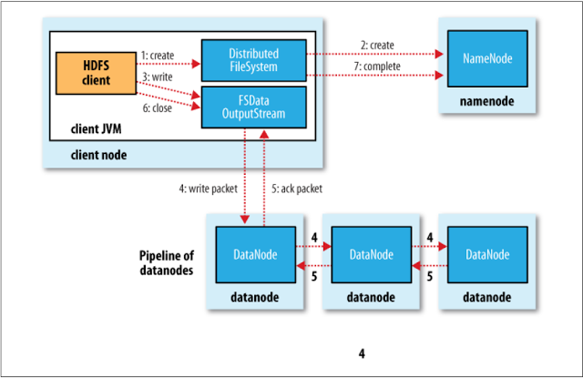

B

A

B

B

B

A

A

A

*Image from Lecture slides*

The client node will notify the namenode about the storing of file sample.data, saying how many blocks the file has. Given that each block needs to be replicated by 3 (default), the client node will write block A, and B on to the 3 datanode sequentially.

When *write* hits the final datanode, an *ack* message will be returned to the previously written nodes recursively, then to the clientnode. At the final step, the client node will notify the namenode to update the metadata of the nodes and the blocks contained.

**(10 points) Problem 5:** In Quorum Consensus algorithm, Reads go to a read quorum of size R and writes go to a write quorum of size W. For a group of **5 replicas**, explain and compare the following three possibilities:

|  |  |
| --- | --- |
| 1) R=5 and W=1   * Improves *writes* at the expense of *reads,* since *write*s can be performed at any one replica. * Bad choice, since *writes* can be performed at 1 replica that later fails, leading to data loss. | 2) R=1 and W=5   * Improves *reads* at the expense of *writes,* we can read from any replica. * Bad for *writes*. If one in the 5 replicas is down, *writes* have to wait until that replica recovers to read W=5 |
| 3) R=3 and W=3   * A good compromise, increasing the cost of reads and providing a reasonable availability of *writes* (W>1 at least) |  |